Recording and Reporting Vaccinations Within Your Clinic’s EMR

Contents
Med Access 1
Creating Vaccination Templates 1
Recording Vaccinations 2
Reporting Vaccinations 3
HealthQuest 7
Recording Vaccinations 7
Reporting Vaccinations 8
Accuro 11
Recording Vaccinations 11
Reporting Vaccinations 12
Wolf 14
Creating Vaccination Templates 14
Recording Vaccinations 15
Reporting Vaccinations 15
PS Suites 16
Recording Vaccinations 16
Reporting Vaccinations 18

Med Access

Creating Vaccination Templates
- Click on Templates in the upper right corner of the main page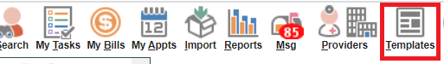
- In the window that appears, select the tab named Imm
- In the top right-hand corner of the Immunization tab, select the New icon
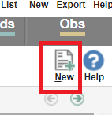
- Fill in the Template Name and Type - if the type of vaccine that you want does not appear, follow instructions 5-6 to create a new Immunization Type.
If you want to report on multiple COVID-19 vaccinations in the future (E.g. List off all patients with no COVID-19 Vaccination), you should add COVID-19 to the Description field. Change the template assignee to Assign to User and click Save.
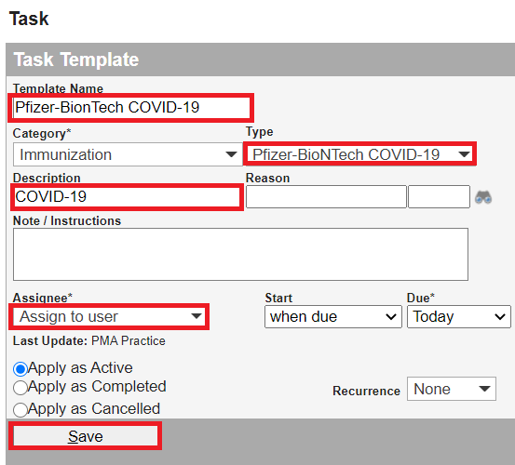

- If the Type of vaccine you desire does not appear, scroll over the Type icon until the New Template icon appears and click it
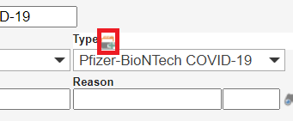
- In the window that appears, type the name of the Immunization in the Description field and click the Add New icon. You can now close the New Type window and return to step 4 to finish creating this Immunization template.
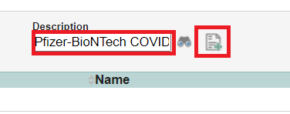
- After saving the template, it will return you to the Immunization template tab, here you can add this vaccination to either Your User favorites and/or Clinic favorites. Click the icon heart that applies, as shown below.

Recording Vaccinations
- Within the patient’s chart, select the Imm tab and right click on the Result icon
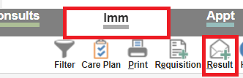
- Select the vaccination template you want (See
- Creating Vaccination Templates if you do not see the template you need)
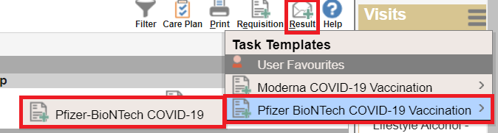

- Fill in any applicable notes in the Note/Instructions field. If this vaccination was done at the clinic, the ordering provider can be added. The date under the observation field should be changed to reflect the actual date the patient had the vaccination administered. When everything has been recorded, select the radio dial Complete this task and click save.
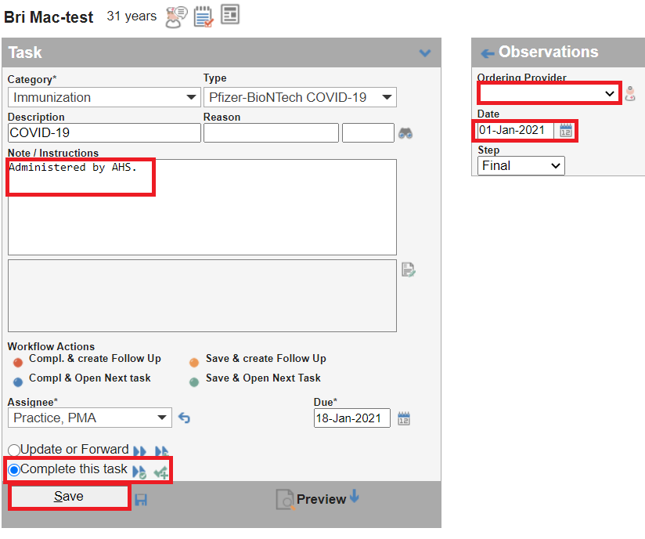

Reporting Vaccinations
- Select the Reports icon on the main page of Med Access
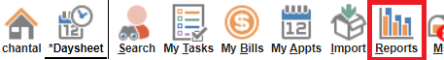

- Select the demographics information you would like to report on. If you are wanting to report on a Primary Care Provider’s entire panel, select their name in the Primary Provider field and select the Status of Active. You may also want this report to only capture certain age groups for this use the Age Range fields.
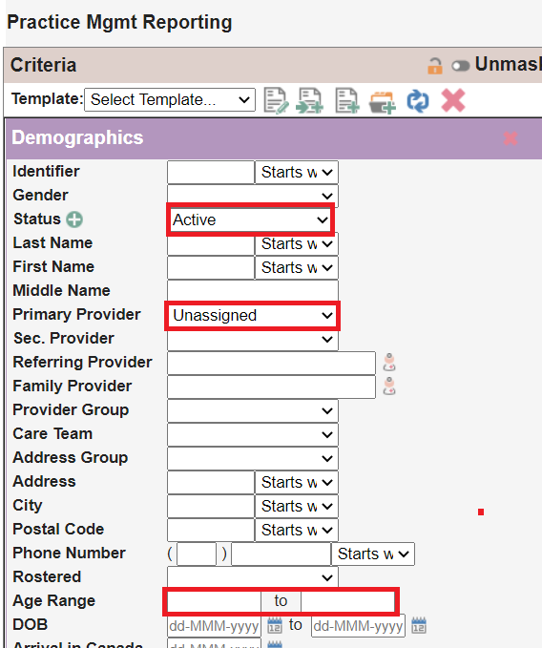
- To report on patients with or without a specific COVID-19 vaccination, in the Task section of the reporting page, select Immunization in the Category drop down. Select the specific vaccination in the Type drop down. Change the Task date, “Back” drop down to All. Change the observation date to reflect the dates of vaccinations you are reporting on. If you are looking for patients WITHOUT this vaccination select the Not checkbox at the top of the Task section, if you are looking for patient’s WITH this vaccination then leave this unchecked.
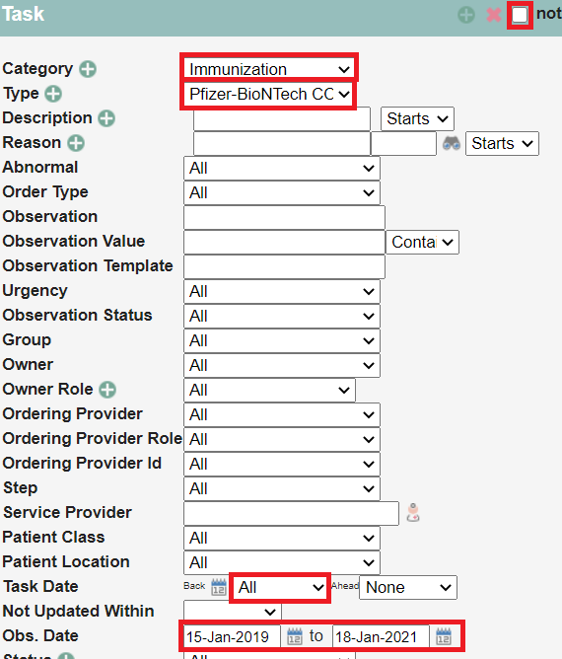
- To report on patients with or without any COVID-19 vaccination, in the Task section of the reporting page, select Immunization in the Category drop down. Type COVID-19 in the Description field. Change the Task date, “Back” drop down to All. Change the observation date to reflect the dates of vaccinations you are reporting on. If you are looking for patients WITHOUT this vaccination select the Not checkbox at the top of the Task section, if you are looking for patient’s WITH this vaccination then leave this unchecked.
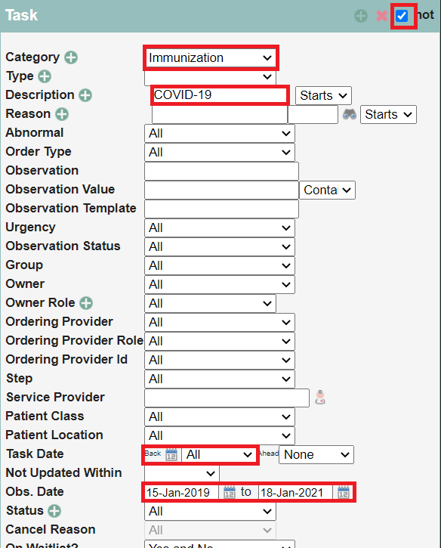
- If you would like to report on whether the patients with specific comorbidities have had or not had a vaccine, follow this step, if not skip to step 6. There are two ways to pull the comorbidities into a report, but this will be specific to your clinic team’s process. If your clinic team is adding accurate information within the Patient’s profile and cleaning these up on an ongoing basis, this may be easier to use then billing information. Billing information will capture all the bills created by a Primary Care Provider so this will ensure no patient is being missed. Below are the two options detailed.
Option #1 – Patient’s Profile Information
Select the green plus button on the Profile bar, this will expand the options as seen below. Select the appropriate Category in the drop down the select the Status as Current. Next, add the diagnosis you would like to report on. If you would like to add more than one diagnostic code, click the green plus button besides Diagnosis, add as many as needed. Now move to step 6.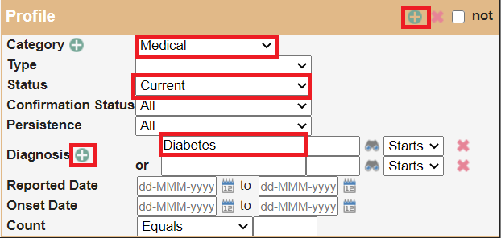

Option #2 – Billing Information
Select the green plus button on the Billing bar, this will expand the options as seen below. Add the diagnostic code that represents the comorbidity you require the patients to have to be included in the report. If you would like to add more than one diagnostic code, click the green plus button besides Diagnosis, add as many as needed. Next, select the Bill date to the date you desire. Now move to step 6.
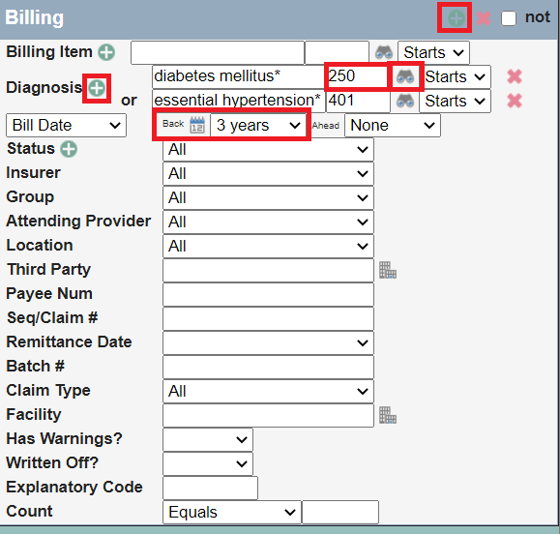

- To get the total number of patients that fit the reporting criteria, select Patient Count (pdf) in the Type drop down to the right of the reporting criteria. If you would like a list of patients that fit the reporting criteria, click the arrow besides Searching, then click the Search icon below that.

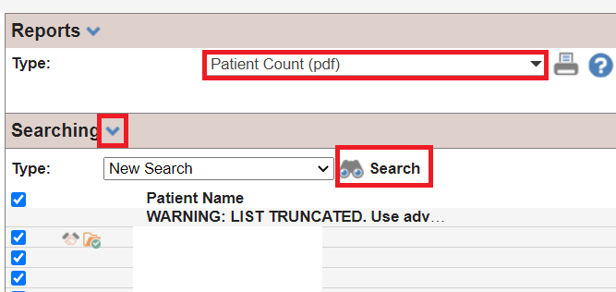

HealthQuest

Recording Vaccinations
There are a number of different options here for recording an immunization a clinic can use for administration, or documentation from another source (netcare, or the patient).
- Use a chart template like shown below. (Call Healthquest and ask for Justik Injection chart note template, or build template with support of your local EMR Expert).
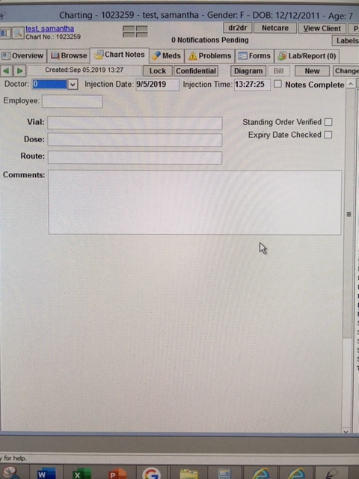
- Use an autocomplete with all relevant information required for reporting.
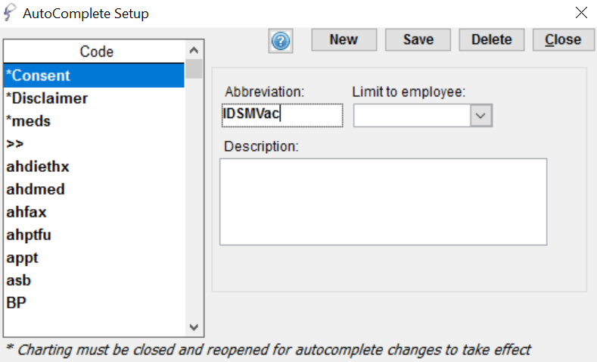
- Click New, enter clinic wide Abbreviation of choice, here in the example is “IDSMVac”
- In the Description, include all the information required for reporting. Double click to open a larger box, add all this information shown below. Hit ok, and save in the box above.
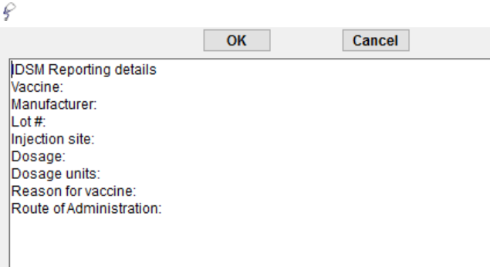
- To execute this Auto-complete in a patient chart note, place cursor where the text is needed, type ‘IDSMVac’ hit space bar and the above should appear ready to be filled out.

Reporting Vaccinations
Setup > Charting Setup > CDS Query Setup
Click on New, in the Desc box at the bottom, call the report IDSM Reporting. Uncheck the checkboxes at the bottom, Save at the top.
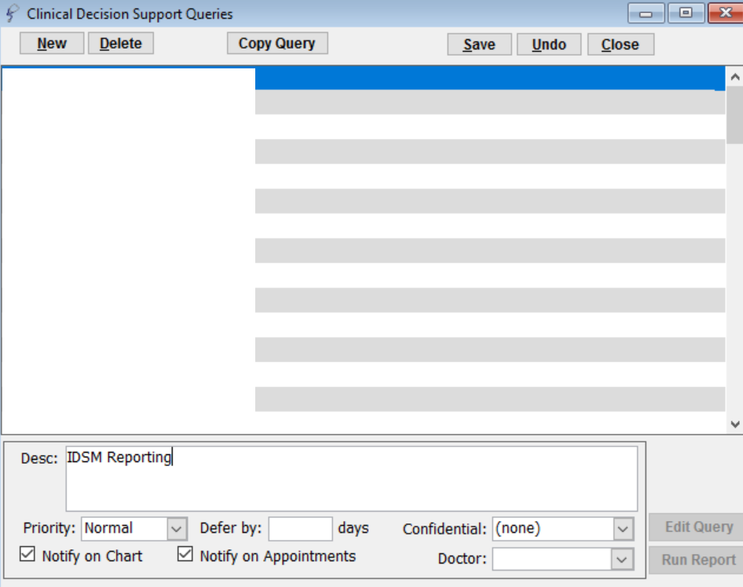
Click on edit Query at the bottom right.
Click New Line and select Clients.
Fill out as shown below, check off default Doctor, and Client type, select appropriate options from the dropdowns and save line.
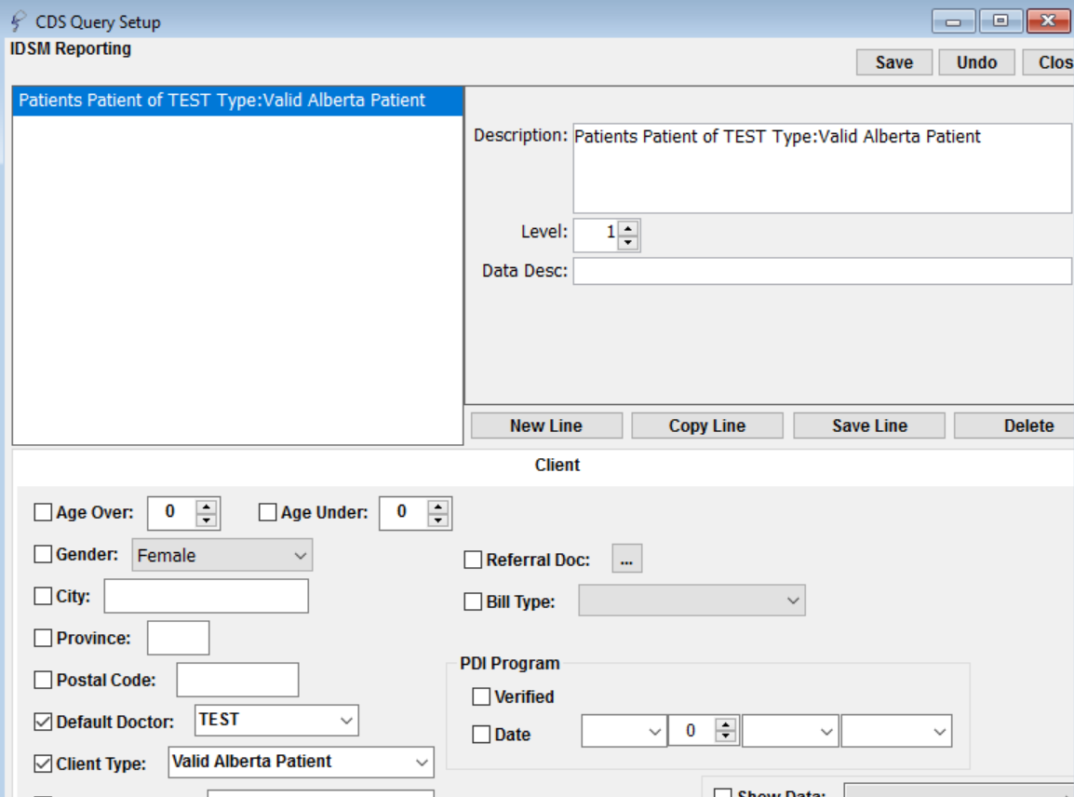
Click New Line, and select Chart Data.
Fill out as shown below, check off visit dates (Under/In the last) 7 days, and any field contains IDSM Report. Save line, and save at the top, and close.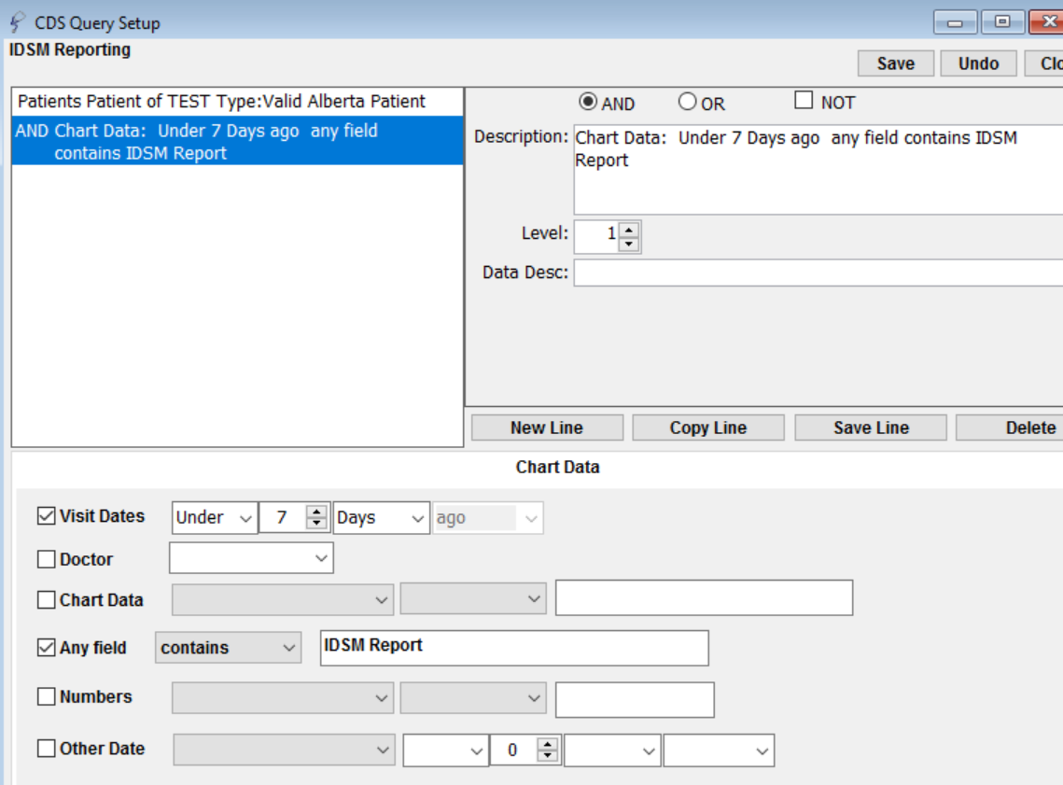
New Line, Click Chart Data again. Fill out as shown below.
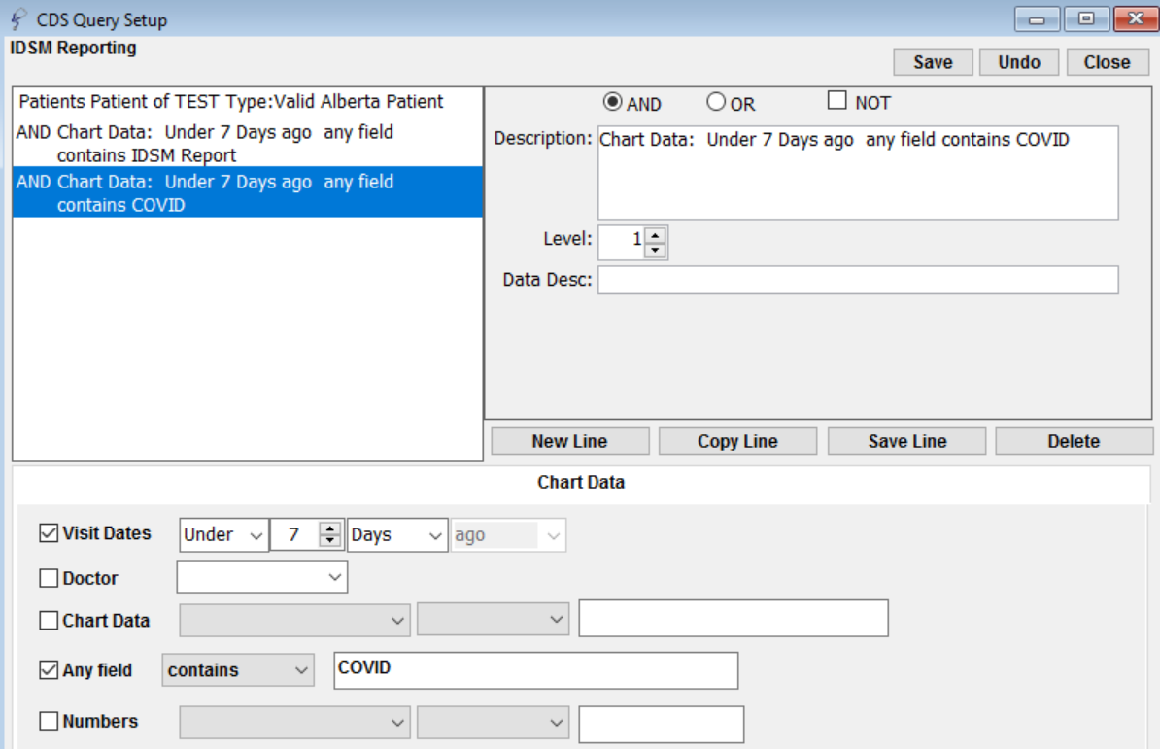
Each week for reporting, go to Setup > Charting Setup > CDS Query Setup. Scroll to find the report name (IDSM Reporting), hit run report in the bottom right of the window.
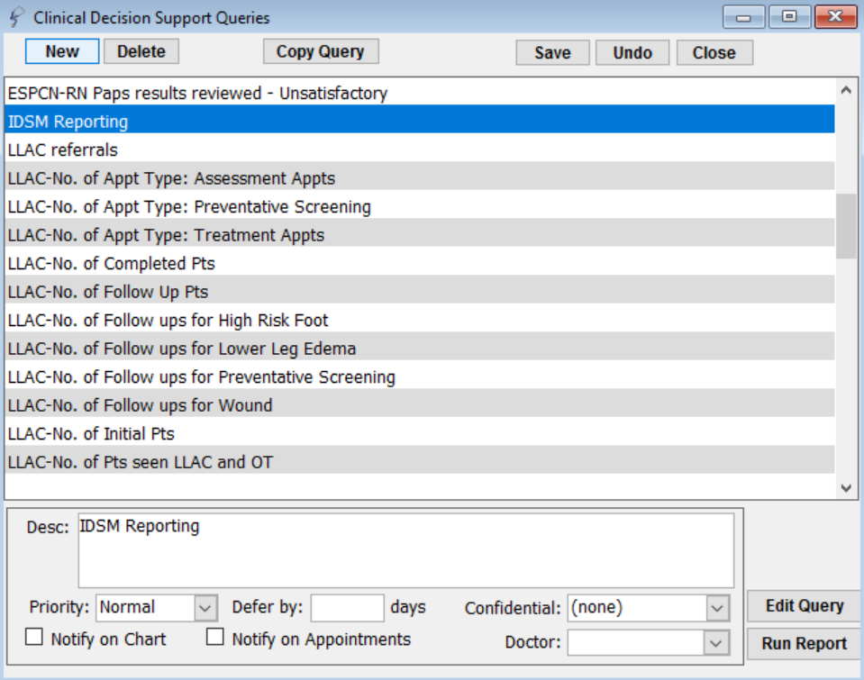
If wanting to know how many COVID Vaccines total, without the week time interval for IDSM reporting, change the time line to 6 months, or 1 year, for both chart data lines.

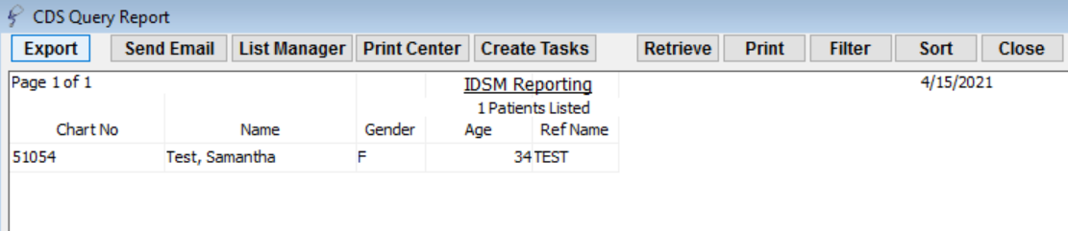

Accuro
*http://services.optimedsoftware.com/Manual/2017/index.htm#t=2338_1.htm&rhsearch=vaccine&rhhlterm=vaccine

Recording Vaccinations
Note: Fields with in the corner are mandatory and must be completed.
- Click the EMR button 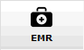 on the Navigation bar and click the Encounter Notes tab.
- Click the next vaccine due on the patient's Immunization Schedule. The Select Vaccine window is displayed, click OK.
Note: More than one vaccine can appear in an immunization age. If you click on a vaccine that has an immunization age higher than the patient's age, a warning message is displayed.
The Patient Immunization window is displayed:
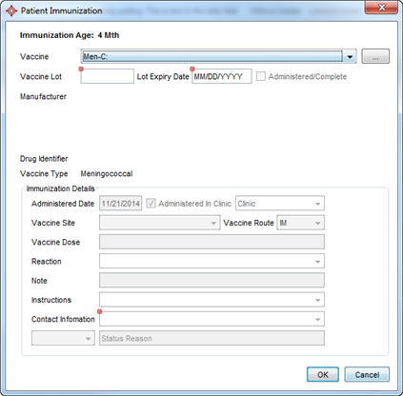
- Click and select the appropriate vaccine from the list displayed.

If the COVID vaccine is not an option in the dropdown:
The two approved COVID-19 vaccination DINs are now available in Accuro. Their Drug Information Numbers are below.
02509210 PFIZER-BIONTECH COVID-19 VACC PFIZER-BIONTECH COVID-19 VACC
02510014 MODERNA COVID-19 VACCINE MODERNA COVID-19 100 MCG/0.5ML
If First Data Bank has not yet been updated in Accuro:
1. Log into Accuro.
2. The 'Update Lists' window is displayed immediately after logging in.
3. Click the check-boxes to select the appropriate update lists.
4. Click 'Update Selected'. You can now click 'Hide Window' and carry on using Accuro while the update list is being updated.
- To select a vaccine not displayed in the drop-down list, click the Ellipses buttonand search on the drug name.
- Select the desired drug and click OK.
- Type in the Vaccine Lot number.
- Choose an Expiry Date.
- Click the checkbox beside Administered/Complete.
- Double-click the Administered Date field and select the date from the calendar displayed.
- If the vaccine was not administered in the clinic, deselect the Administered in Clinic checkbox, click and select a location from the list displayed.
- Click and select a Vaccine Site from the list displayed.
- Click and select a Vaccine Route from the list displayed.
- Click and select a Reaction from the list displayed, if any.
- Type any additional information in the Note field, if required.
- Click and select Contact Information from the list displayed.
- Click OK.

Reporting Vaccinations

Click the Accuro Target in the bottom left corner, hover over reports, and select Query builder.

Select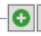 and give the search a name, such as “IDSM reporting”, hit ok.

In the drop down shown on the next page, under new rule, select immunizations, then select immunizations again.
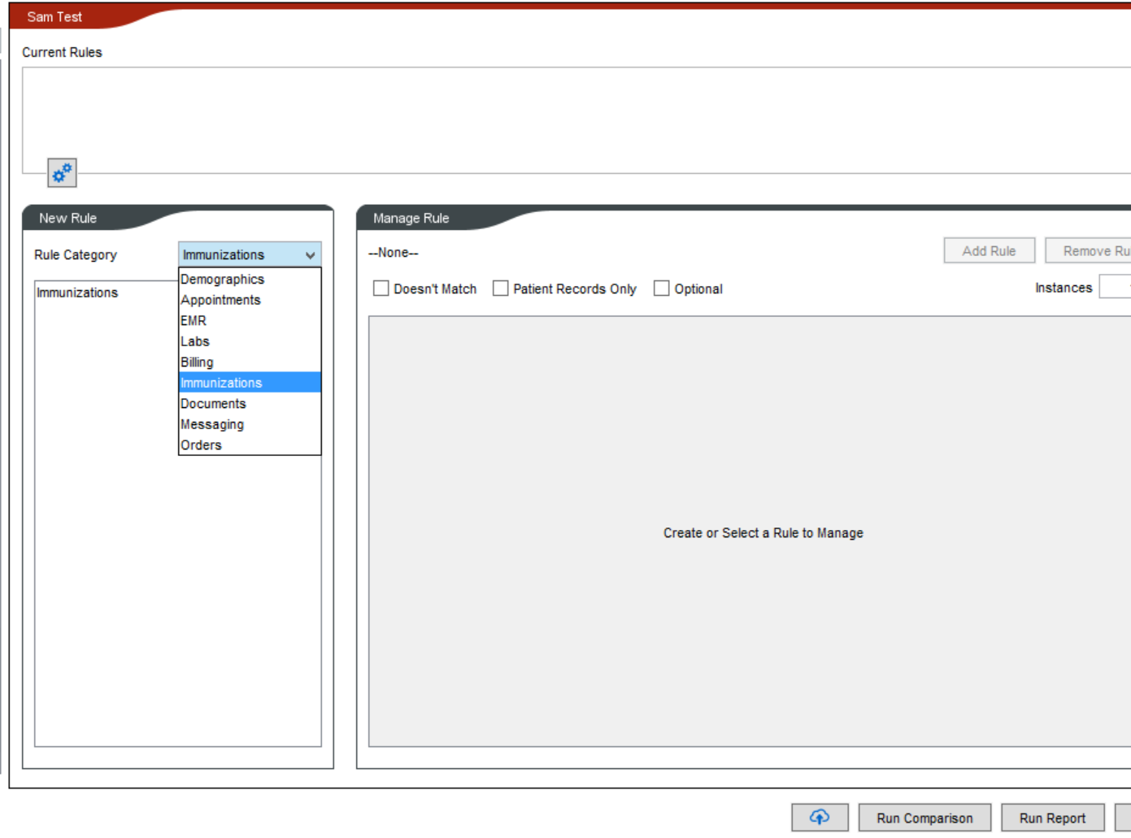
See the below window, click new, and select date administered and fill out, “in the last week”
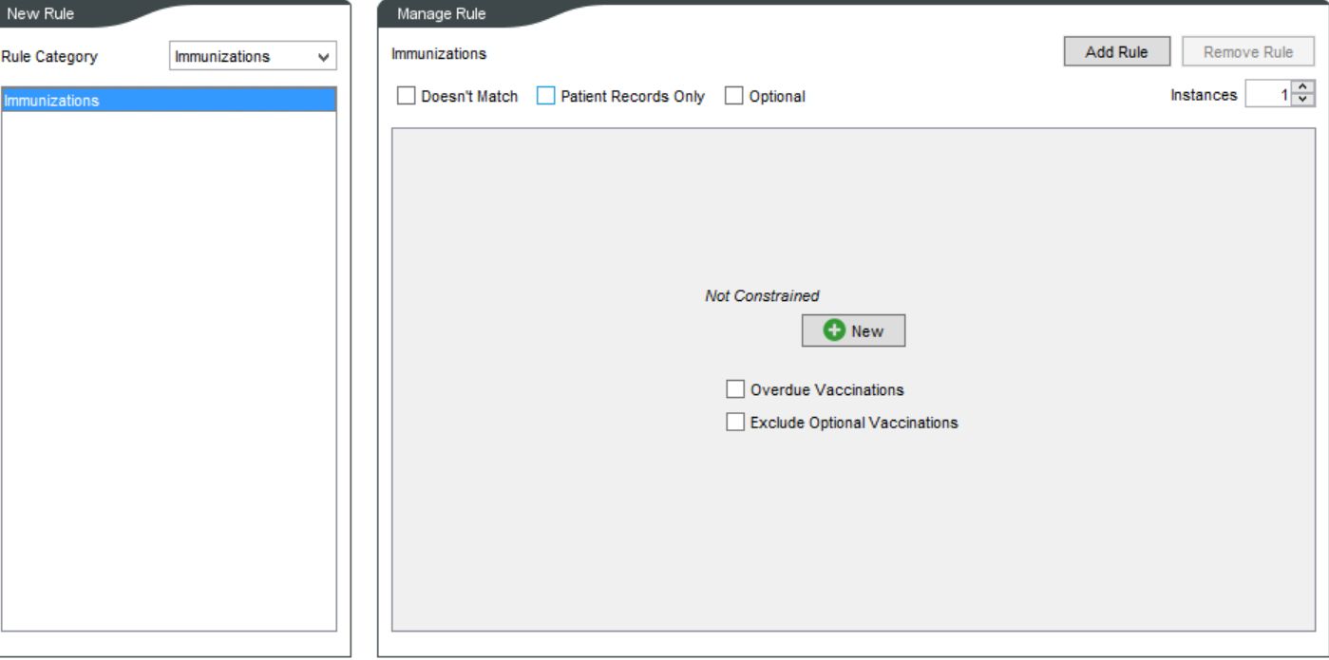
If wanting a list of patients with or without a specific vaccine, instead of clicking date administered, select Vaccine/Immunization.
Select add rule.
Hit Run report in the bottom right corner of that window.
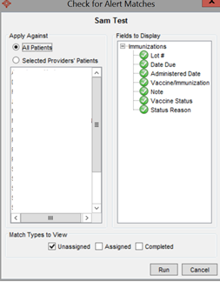
Select one provider at a time, or run the whole clinic, and run. The list will appear, with all the columns with the above information, shown on the right-hand side of that above window.

Wolf

Creating Vaccination Templates
- In the Work Desk, select the Configure tab and click Edit Vaccination Types Lots
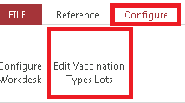

- In the window that appears, enter a Vaccine Type, Brand Name, and Manufacturer. Once the template is correct, click the “plus sign” icon then click the exit icon. 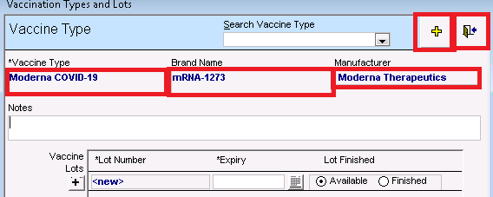

Recording Vaccinations
- In the patient’s chart - Medical Summary, select Add Vaccination in the Vaccinations section.
- In the window that appears, add the correct Vaccination Date, Vaccination Name, Lot # (this is a mandatory field, if Lot# is unknown then type in 00000), and Vaccination Injection Site, then click the exit icon in the top right corner. (See Creating Vaccination Templates if the Vaccination Name that you need does not appear)
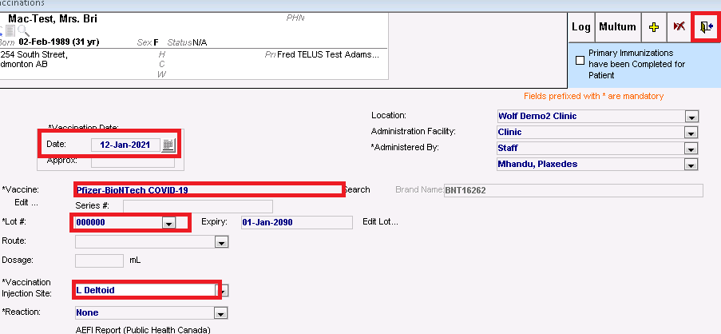

Reporting Vaccinations

- Within the main Wolf EMR screen, select Practice Search at the top
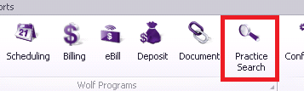

- In the window that appears, on the left-hand side, select Status, Patient MD, and Vaccinations. After those have been selected fill in the Patient status drop-down to reflect the active panel and select the Primary Care Provider the report is for within the drop down. Below both options, the vaccination field will be available, type the vaccination(s) you are reporting on and click Add or the “plus sign” icon to add them to the reporting criteria. When all the vaccinations have been added, select the patient report icon at the top right corner of the window.
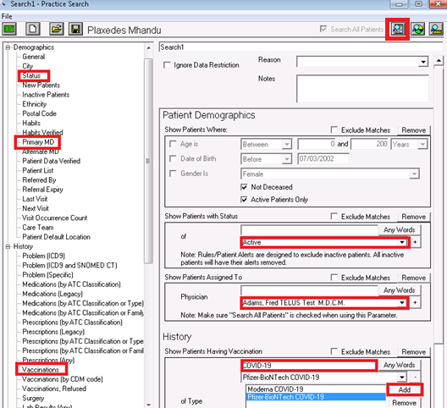

PS Suites

Recording Vaccinations
- Within the patient’s chart, select the Imm title
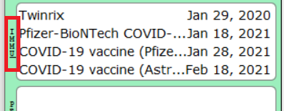

- Within the name field, type part of the vaccination name and then click Tab.
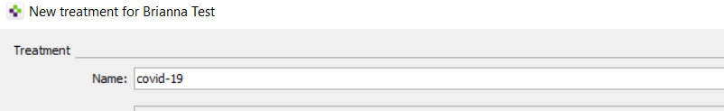

- In the window that appears, select the correct vaccination name and click Choose.
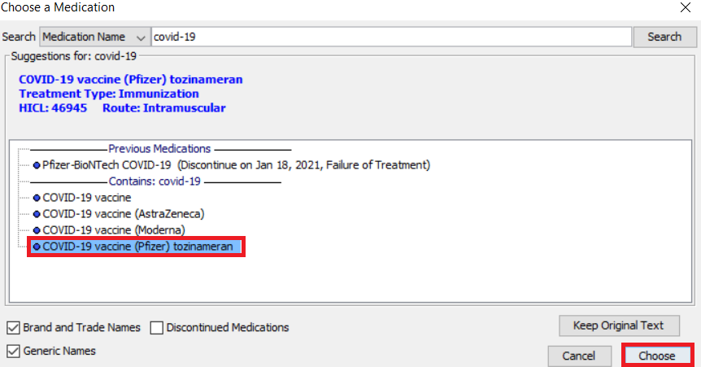
- The full vaccination name should appear now within the first window. If this vaccination is being administered at your clinic, enter the Administration Details. If this vaccination was done by another healthcare site, check off the option for Started/Performed by External Provider and then add the Provider Name. Select the date the vaccination was administered in the Start/Perform Date field at the bottom of the window. Then click Perform Immunization once all the information on this window is correct.
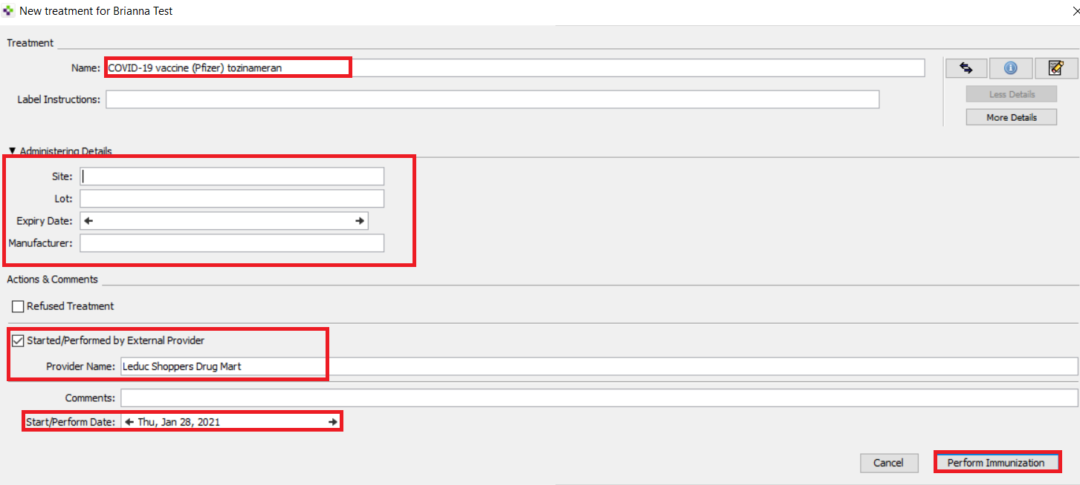

Reporting Vaccinations
- In the main PS Suites window, select Records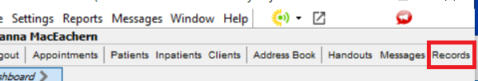
- Within the window that appears, select the Setting dropdown and click Edit Searches…
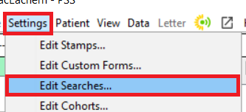
- Within the Searches window, else the Edit dropdown and click Add Search
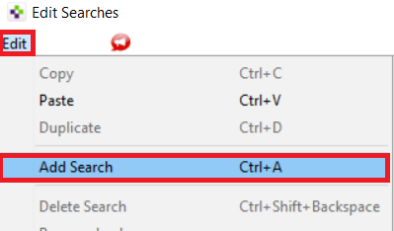
- Add the title of your search into the Search Name field and click Add Line
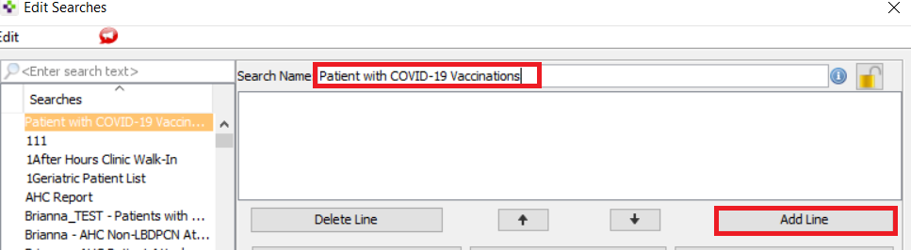

- Select Demographics, Patient Status, select the equal sign and then select the status that reflects the clinic’s active patients. After this is correct, select OK.
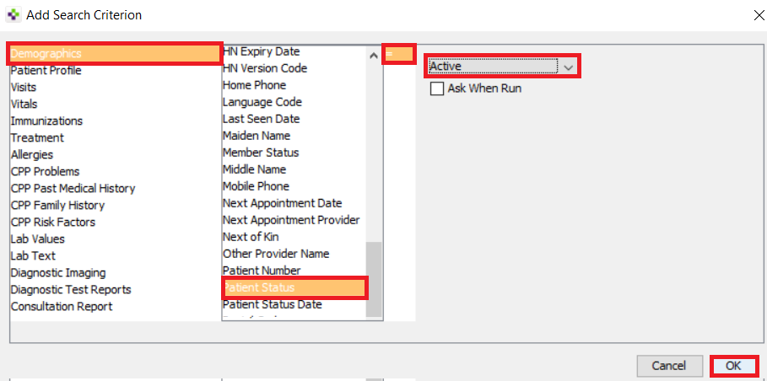
- Select Add Line again.
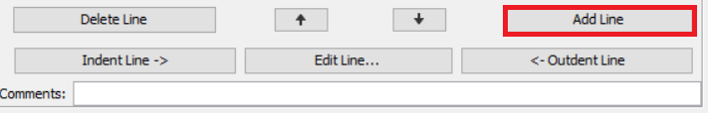

- Select Patient Profile, then IMM/Immunization then Contains the Word then type either a partial name or the specific drug name within the available field. Once this is complete, click OK. *Note: if you are trying to find a list of patients that have not received the vaccination, select Patient Profile, IMM/Immunization then Does Not Contain The Word, instead and then follow the same reporting instructions following this step.

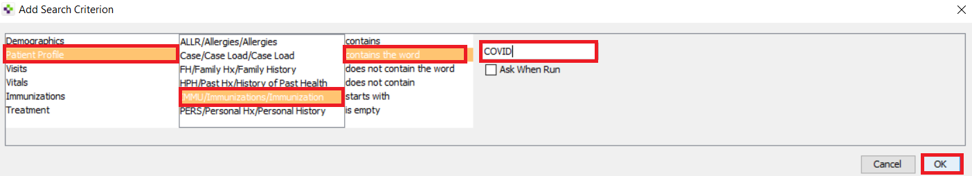

- Select Perform Search within the Searches window.
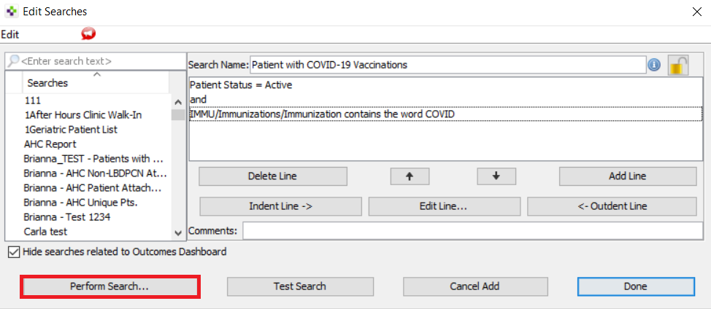
- Select Uncheck All Doctors and individually select the physicians you would like to run the report on. Then click Search.

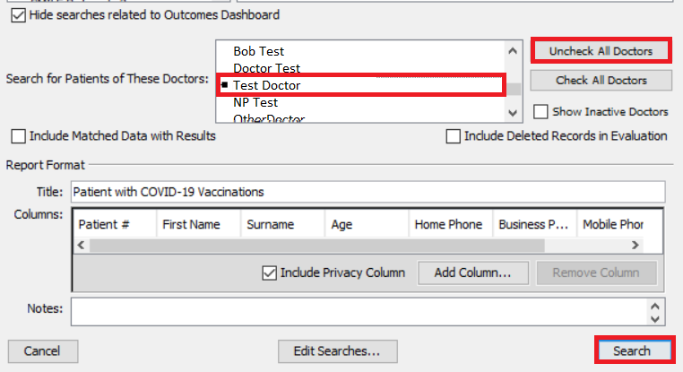
- A list like shown below should appear in another window.