2017 AMA Medical Student Bursary

The bursary

The Alberta Medical Association (AMA) is pleased to announce the AMA Medical Student Bursary, which provides financial assistance to Alberta medical students who require assistance with the high costs associated with medical school.

The AMA Medical Student Bursary Program is made possible through generous donations by physician members and the raised funds from the Annual North South Doctors Golf Tournament, which the AMA co-hosts with the College of Physicians & Surgeons of Alberta (CPSA) and the Canadian Medical Foundation (CMF) each July.

Who’s eligible?

The AMA Medical Student Bursary is available to AMA/CMA members in good standing, who are also enrolled full-time in undergraduate medical education in an Alberta medical school at the time the bursary application is made.

How much is available?

In 2016, $87,000 was awarded to medical students qualifying for the bursary. The funding will be apportioned to each medical school based on the number of enrolled students in each school.

Each individual bursary will be an award of $1,500.

When to apply

Your AMA student representative will email all classes in October to notify you of the open competition. Applications for the bursary will be accepted until December 31, 2016. Applications received after this date will not be considered. Applications can be completed on-line at https://www.albertadoctors.org/about/awards/ama-student-bursary

Selection process

Awarding of bursaries will be based on financial need. The Selection Committee consists of one AMA management staff and one representative from each of the University of Alberta and University of Calgary faculties of medicine.

Bursary recipients will be notified in writing after the selection process is completed (February 2017). The names of the award winners will be published in MD Scope and on the AMA website in March.

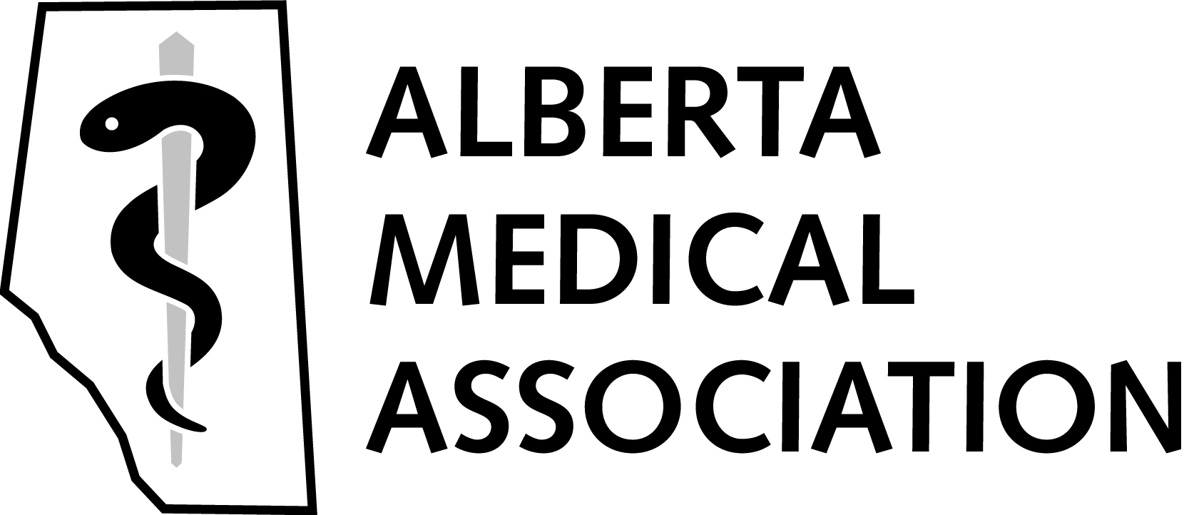
October 2016

